Annual Assessment of Graduate Student Progress Form
OSU Applied Anthropology Graduate Program

Student Name: _________________________ Date of Assessment: ________________

Please carefully review information about the AAGP Annual Assessment of Progress in your program handbook and complete in accordance with AAGP guidelines. Incomplete assessments will not be accepted.

This completed form must be attached to the self-assessment narrative and submitted to the Applied Anthropology Graduate Program Coordinator by June 30th each year.

1. Completion of Milestones:
Student: Please enter the term of completion (e.g. ‘Winter, 2018’) next to milestones achieved for your current degree.

Committee formed (Enter names at right): ____________________________ | Major Professor Name(s): | Dept:
Conducted program of study meeting: _______________________________ | _________________________ | _____________
Submitted program of study to Anthropology Office: ____________________ | _________________________ | _____________
Defended research proposal (PhD only): ______________________________ | Committee Member Names: | Dept:
Received IRB approval for research: _________________________________ | _________________________ | _____________
Submitted program of study to Grad School: __________________________ | _________________________ | _____________
Comprehensive scheduled for (PhD): ________________________________ | _________________________ | _____________
Comprehensive Exam passed (PhD): _________________________________ | _________________________ | _____________
Final Defense scheduled for: _______________________________________ | _________________________ | _____________

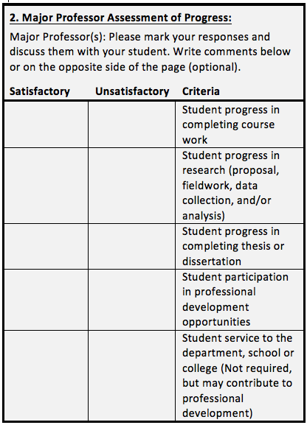
3. Signatures:

I have reviewed my student’s milestones (section 1) and self-assessment narrative, completed the ‘Major Professor Assessment of Progress’ (section 2), and discussed my responses with my student.

_________________________________ ______________

_________________________________ ______________
Major Professor Signature(s) Date

_________________________________ ______________

_________________________________ ______________
Committee Member Signature(s) (optional) Date

I have completed section 1, written and attached my self-assessment narrative, and understand my major professor(s)’ assessment of my progress (section 2).

_____________________________ ______________
Student Signature Date

Major Professor Comments (optional; use opposite side of page if necessary):

