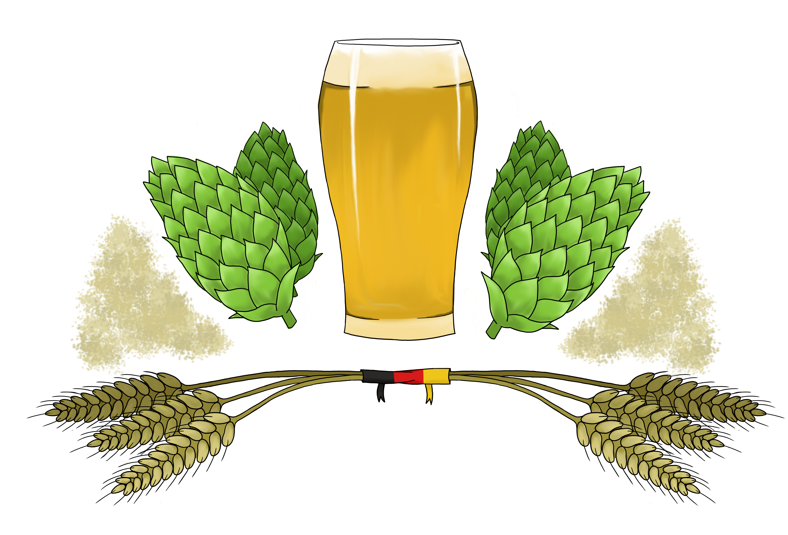

German Beer Culture – Summer Seminar in Germany
Pre-Trip Course: June 15-19, 2015
Travel Dates: June 23-July 2, 2015

First Name
Last Named
DOB

Major/Minor
Year

Have you ever been abroad? Where and for how long?

Have you had any German? (German is not required for participation in this program, but it will be helpful for us to know if participants have had any German.)

Do you have a passport? Applicants will be informed by March 15. If you are accepted and do not have a passport, you must apply for one by March 31st.

Personal Statement – On the back of this application, please tell us why you are interested in this study-abroad experience.

Send completed application to Bradley Boovy (bradley.boovy@oregonstate.edu) and Sebastian Heiduschke (sebastian.heiduschke@oregonstate.edu) by
March 11, 2015.

