New Online Third-Year Chinese (CHN 311, 312, 313)
Fall, Winter, Spring, 2022-2023

Location: E-campus
Credits: 3, 3, 3
Prerequisites: 2 years of college level Chinese or instructor approval, open to heritage speakers, required for the Chinese minor

Come and learn the language spoken by more than 1 billion people (>1/6) in the world. Expand your intellectual horizon and career opportunities by mastering this critical language. Chinese is designated as a critical language by the US government.
This course combines language acquisition with learning about Chinese culture and society. It focuses on practical application of the language in everyday situations. Course work consists of reading, writing, grammar exercises, conversation and discussion, and watching short videos of China’s famous scenic spots and historical sites.

Topics  开学/介绍  XXXX  吃饭  买东西  交友  XXXX  XXX | 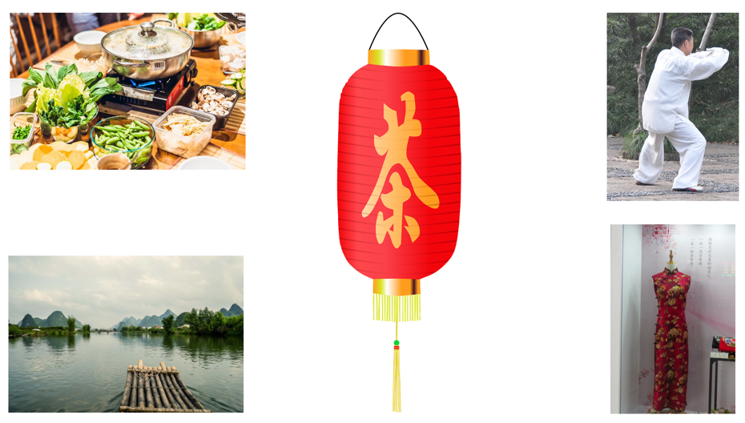

For more information, contact Shiao-ling Yu (syu@oregonstate.edu) or Youning Li (liyou@oregonstate.edu)

